**WALRUS MOTOR AND POWER DISTRUBUTION CIRCUIT**

**E STOP**

**Alternative 1 : XBee S2C RF Module – 10m Range**

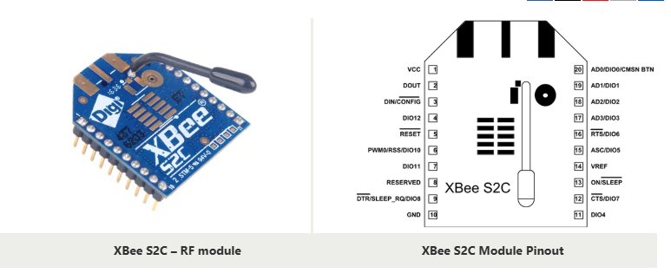

**Alternative 2 : nRF24L01 Transreceiver Module – 100m Range**

The NRF24L01 transceiver module. It uses the 2.4 GHz band and it can operate with baud rates from 250 kbps up to 2 Mbps. If used in open space and with lower baud rate its range can reach up to 100 meters.

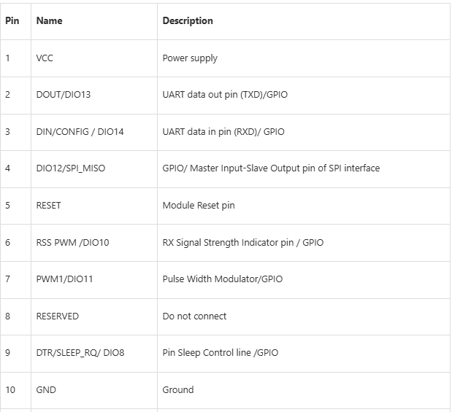

**Features and Electrical Characteristics**

* Transmission Frequency: 2.4GHz to 2.5GHz
* Number of Channels: 16 Direct Sequence Channels
* Featured with UART (250 Kb/s maximum) and SPI (5 Mb/s maximum) interface
* Featured with software adjustable transmitting power
* Indoor/Urban Range: 200ft
* Outdoor RF line-of-sight Range: up to 4000ft
* Transmit Power Output: 6.3mW (8dBm) in Boost mode,2mW (3dBm) in Normal mode
* RF Data Rate: 250,000 bps
* Receiver Sensitivity: -102dBm in Boost mode, -100dBm in Normal mode
* Supply Voltage Range: +2.1V to +3.6V
* Operating Current: 33mA (at3.3V, for Normal mode) , 45mA (at 3.3V,for Boost mode)
* Idle Current: 9mA
* Maximum output current on all pins together: 40mA
* Power-down Current: <1uA @25C
* ESD protection: 3000V
* Operating Temperature: -40ºC to 85° C

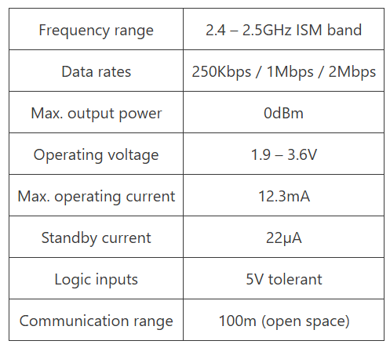

The module can use 125 different channels which gives a possibility to have a network of 125 independently working modems in one place. Each channel can have up to 6 addresses, or each unit can communicate with up to 6 other units at the same time.

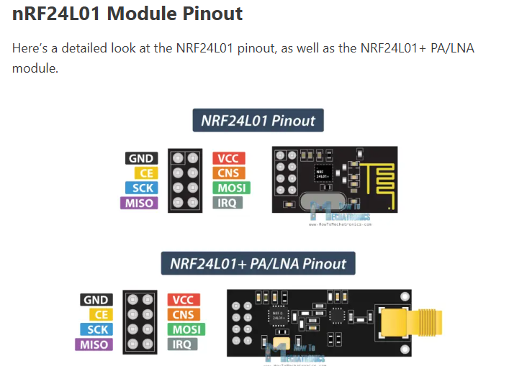

Reference : - <https://howtomechatronics.com/tutorials/arduino/arduino-wireless-communication-nrf24l01-tutorial/#h-overview>

**ALTERNATIVE 3 LORA – upto 200km**

**Simplified Military-Inspired E-Stop System Design**

**1. Core Requirements**

* **Range**: 200 km.
* **Latency**: Near-instant communication for safety.
* **Reliability**: Resistant to interference and failure.
* **Security**: Prevent accidental or malicious activation.
* **Power Management**: Efficient operation for long durations.

**2. Communication Method**

For a 200 km range, a **cellular-based approach** (e.g., 4G/5G) or **LoRaWAN** with a gateway is practical. We'll use **LoRa point-to-point** if no gateways are available, or **cellular (4G/5G)** for simplicity and broader coverage.

* **Option 1**: **LoRa Point-to-Point Communication**
  + Modules: **RFM95** or **SX1276/78** LoRa transceivers.
  + Frequency: 868 MHz (EU) or 915 MHz (US).
  + Range: Up to 200 km with high-gain antennas.
  + Security: Enable AES-128 encryption.
  + Advantage: No reliance on existing infrastructure.
* **Option 2**: **Cellular Communication**
  + Modules: **SIM7600** (4G) or **Quectel EC25**.
  + Network: Requires a SIM card with coverage in your area.
  + Security: Use HTTPS or MQTT with encryption for data transfer.
  + Advantage: Global coverage with existing infrastructure.

**3. System Components**

* **Transmitter (Remote Control Unit)**:
  + Microcontroller: Arduino, STM32, or ESP32.
  + Communication Module: LoRa or SIM7600.
  + Input: Push-button for E-Stop.
  + Power Supply: Rechargeable battery (e.g., LiPo).
* **Receiver (Bot Unit)**:
  + Microcontroller: STM32 or Arduino.
  + Communication Module: LoRa or SIM7600.
  + Output: Relay module to cut off motor power.
  + Safety: Fail-safe design to stop motors if communication is lost.
  + Power Supply: Same source as the bot.

**5. Software Design**

* **Transmitter Code**:
  + Monitor the push-button state.
  + On button press, send an encrypted **E-Stop signal** (e.g., "STOP") to the receiver.
  + Add acknowledgment from the receiver for redundancy.
* **Receiver Code**:
  + Continuously listen for the **E-Stop signal**.
  + On receiving "STOP," immediately activate the relay to cut off power to motors.
  + Implement a **watchdog timer**: If no signal is received for a specified period, stop the bot automatically.

**6. Security Features**

* **Encryption**: Use AES-128 or TLS for secure communication.
* **Frequency Hopping (LoRa)**: Change frequencies dynamically to prevent jamming.
* **Authentication**: Verify sender identity using pre-shared keys or certificates.

**7. Hardware Recommendations**

* **Microcontroller**: STM32F401CCU6, ESP32, or Arduino Nano.
* **LoRa Module**: RFM95 (868/915 MHz) or SX1276/78.
* **Cellular Module**: SIM7600 or Quectel EC25.
* **Relay Module**: 5V or 12V relay board.
* **Antenna**: High-gain directional antennas for LoRa.
* **Power Supply**: 3.7V LiPo battery with a step-up converter.

**8. Example Use Case**

* When the emergency button is pressed on the transmitter, it sends a secure "STOP" signal.
* The receiver decodes the signal and activates the relay to disconnect the battery from the bot's motors.
* If the receiver loses communication with the transmitter for more than 2 seconds, it triggers the E-Stop autonomously.

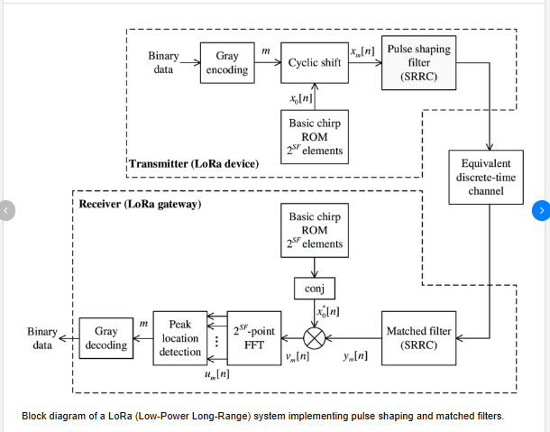s